

RELIGION AND LIFE DRAFT SAMPLE EXAMINATION

STAGE 3

Section 7 of the WACE Manual: General Information 2008 Revised Edition outlines the policy on WACE examinations.

Further information about the WACE Examinations policy can be accessed from the Curriculum Council website at http://www.curriculum.wa.edu.au

The purpose for providing a sample examination is to provide teachers with an example of how the course will be examined. Further finetuning will be made to this sample in 2008 by the examination panel following consultation with teachers, measurement specialists and advice from the Assessment, Review and Moderation (ARM) panel.

2008/22392[v2]




Western Australian Certificate of Education, Draft Sample External Examination

Question/Answer Booklet

RELIGION
Please place your student identification label in this box
AND LIFE
WRITTEN PAPER
STAGE 3

Student Number: In figures

In words

Time allowed for this paper
Reading/planning time before commencing work: Ten minutes
Working time for paper: Three hours

Material required/recommended for this paper

To be provided by the supervisor
Question/Answer Booklet

To be provided by the candidate
Standard items: Pens, pencil, eraser or correction fluid, highlighter, ruler.
Special items: Nil

Important note to candidates
No other items may be taken into the examination room. It is your responsibility to ensure that you do not have any unauthorised notes or other items of a non-personal nature in the examination room. If you have any unauthorised material with you, hand it to the supervisor before reading any further.

Structure of this paper

Section | Suggested working time | Number of questions available | Number of questions to be attempted | Marks | Weighting
Section One | 35 minutes | 2 | 2 | 30 | 22
Section Two | 75 minutes | 3 | 3 | 55 | 39
Section Three | 70 minutes | 4 | 2 | 55 | 39
 |  | [Total marks] |  | 140 | 100

Instructions to candidates

- The rules for the conduct of Curriculum Council examinations are detailed in the Student Information Handbook. Sitting this examination implies that you agree to abide by these rules.

- For Sections One, Two and Three, write your answers in the spaces provided in this Question/Answer Booklet. A blue or black ballpoint or ink pen should be used. Wherever appropriate, fully labelled diagrams, tables and examples should be used to illustrate and support your answers. Pencil may be used for diagrams.

- You must be careful to confine your responses to the specific questions asked and to follow any instructions that are specific to a particular question.

- Spare answer pages may be found at the end of this booklet. If you need to use them, indicate in the original answer space where the answer is continued (i.e. give the page number).

SECTION ONE—RELIGIOUS INQUIRY AND PROCESSES [30 marks]

This section has THREE (3) questions. Attempt ALL questions.

Suggested working time: 35 minutes

Question 1
Study the information and graphs shown below and answer all the questions

Religious Participation in Australia
Many Australians see themselves as belonging to a religion. A sense of belonging to a religion is known as ‘religious affiliation’ and is often expressed through participation in church and other religious activities.
The participation of Australians in religious activities is represented in Graphs A.1 and A.2.
Graph A.1 indicates the gender differences in religious affiliation rates between any religion and Christianity.

Affiliation Rate (%)
Graph A.1: AGE/SEX AFFILIATION RATES—2001
50
60
70
80
90
10
20
30
40
50
60
70
Age (years)
Any religion, female
Any religion, male
Christian, female
Christian, male
[From: Australian Bureau of Statistics, 2001]

Note: Ages are not exact but are representative of a age group

- Outline the pattern of religious affiliation in graph A.1.
[3 marks]

Graph A.2 shows the rate of participation in church or religious activities and the rate of participation in unpaid voluntary work for a religious organisation.

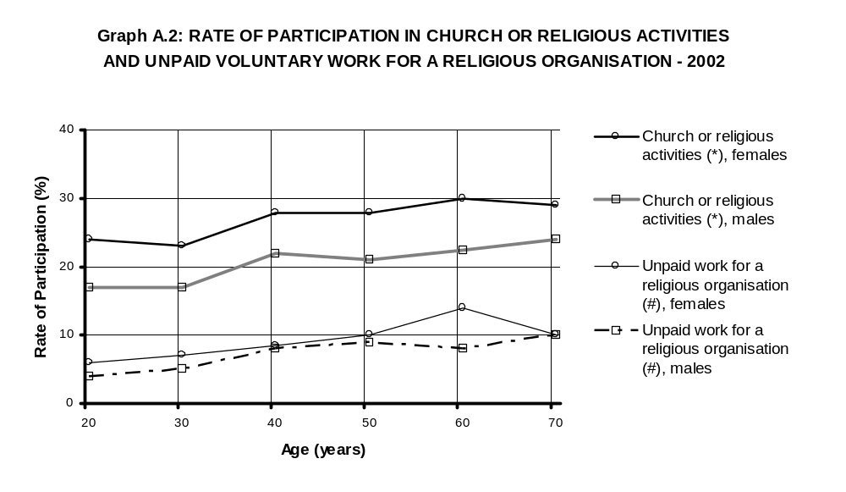
(*) Participated in church or religious activities within the previous three months.
(#) Did unpaid voluntary work for a religious organisation within the previous 12 months.

[From: Australian Bureau of Statistics, 2002]

Note: Ages are not exact but are representative of an age group

- Outline the pattern of participation in church or religious activities in graph A.2.
[3 marks]

Question 1 cont.
- Account for the trends in religious participation of Australians from graphs A.1 and A.2.
[6 marks]

Question 2
Read the following two extracts, Research and Religion and Topics of Research and then complete the tasks that follow.

Extract One: Research and Religion
In an interview that appeared in the Journal of Psychology and Christianity in 2003, psychologist Everett L. Worthington Jr talked about his calling and mission as a Christian researcher. His approach to research is best summed up in the following quote:

I do research on things that are scripturally approved, such as forgiveness and reconciliation. Scripture is not a marriage counselling manual. Research helps us to flesh out the principles that Scripture advocates.

I also pray about my research career and reflect prayerfully on it. Often people who are doing research in marital issues will have an active prayer life about their own relationships, the sins in their lives, and other life decisions. Yet they may rarely seek God's guidance about how God wants their research careers to progress. Our research direction can influence our entire life, not just the work that we do from 8 to 5. Surely something this important deserves prayer and listening for God's direction.

Extract Two: Topics of Research
Conducting research topics relevant to religion may be easier in some disciplines than others. Some possible topics that may come under the general banner of religious based research include:
- Studies that include beliefs (or more general religiosity) as one of the variables of interest. For example, there is a growing body of evidence in disciplines such as psychology, nursing, and medicine that healthy religious commitments enhance general health and well-being. Studies of grief, loss, and bereavement could also benefit from the inclusion of religious beliefs.
- Studies that include religious concepts such as forgiveness. Such studies are making their way into mainstream psychology journals as secular researchers are also starting to realise that forgiveness is an important key to moving on (e.g., in studies of divorce or abuse).
- Studies that look at pro-life issues (e.g., abortion and euthanasia) and issues of medical ethics (e.g., reproductive technology; stem-cell research etc).
- Any studies that look at topics compatible with a religious framework, though not necessarily unique to one particular religion. For example, helping people to develop:
  - healthy relationships,
  - good communication and social skills,
  - good problem-solving or decision-making skills, or
  - prosocial behaviours [positive social behaviour].
[Passmore, 2005]

- With reference to the viewpoints expressed in these two extracts and examples drawn from your own study discuss the advantages and disadvantages of conducting research influenced or shaped by a religious perspective.
[10 marks]

- Based on the viewpoints expressed in these two extracts, how might the authors of these viewpoints address TWO of the following issues in research?

  - research excellence
  - ethical conduct
  - selection of research topic
  - research methods
[8 marks]

END OF SECTION ONE
SECTION TWO—THE NATURE OF RELIGION [55 marks]

This section has THREE (3) questions. Attempt ALL questions.

Suggested working time: 75 minutes

Question 3
Read the following quote and then complete the tasks that follow:

One of the dominant themes in the contemporary world is a revived interest in spirituality. Spirituality is booming and blooming. The desire for a deeper, more profound life finds a wide variety of expressions, oftentimes different from the traditions and forms of a particular religious upbringing.
[From: Ryan, 2004]

- Outline one factor contributing to a desire amongst individuals and/or groups for a deeper, more profound life?
[3 marks]

- Describe one way in which contemporary people may pursue meaning and purpose in their lives through their spirituality and/or expressions of religion.
[3 marks]

- Outline how one person from the present or the past struggled with and/or pursued a spiritual journey in search of meaning and purpose in their life.
[9 marks]

Question 4
Read this article and complete the tasks that follow:

Inspirational Amish set us a fine example

Forgiveness liberates those who forgive as well as those who are forgiven

Hugh Mackay-The Moral Maze

Who could fail to have been moved - perhaps even inspired – by the response of the Amish community of Nickel Mines, Pennsylvania, to the slaughter of five of their little girls? Which of us would have been so ready to visit the gunman’s family in a spirit of forgiveness?  The so-called “Christian values” highlighted by this tragedy are not the exclusive domain of particular churches or sects, nor even necessarily of any religion. There’s much talk about values, Christian and otherwise, in Australia at present and Kevin Rudd’s recent public ruminations about the relevance of Christian values to politics have sharpened the debate. Yet the quintessential Christian values – freedom, peace, justice, reconciliation – might be seen as characteristic of any truly civil society.  It is a sad aspect of life in contemporary Australia that we need to go back to basics with our discussion of ethics in the political context. Should we really need to be reminded that political deceitfulness (whether in the form of slick spin-doctoring or outright lying) corrodes our political culture? Should governments really need to be told to be more responsive to the needs of the poor, the sick, the disadvantaged, the bewildered and the marginalised?  Such matters lie at the heart of Christianity, but they also attract the attention and concern of people of other faiths or of no religious faith at tall. Still, Mr Rudd’s point remains valid; it is part of the role of religion to inspire us with a vision of a better world, to shine light in dark places, and to bring out the best in us – believers and non-believers alike.  But perhaps the Christian spirit of forgiveness, so powerfully expressed by the Amish response to the massacre of their children, challenges us to a higher plane of mortality than most of us would willingly or easily go. | This in not a uniquely Amish position of course: the injunctions to “turn the other cheek” and to “forgive and you will be forgiven” are central to Christianity in all its varieties. Along with humility, the define core Christian virtues.  As with most moral injunctions that encourage us to act in ways that promote social harmony, the call to forgiveness is soundly based on human psychology. When the English poet Alexander Pope wrote that “to err is human; to forgive, divine” he was really saying that when we forgive, there’s a touch of the “divine spark” in us.  Forgiveness is the human action that takes us closer than any other to the ideals of goodness and wholeness.  Forgiveness is a liberating, therapeutic experience for those who forgive and for those who are forgiven. It is one of the most generous acts we ever perform. It helps us realise that other people can be valued and accepted with all their shortcomings and frailties. We forgive people not because we think they are “not really like that”, but because we know they are really like that and that’s precisely why they need our forgiveness.  Where an apology has been offered, forgiveness is the only valid symbol of the acceptance of that apology. (A formal apology to Aboriginals for the wrongs done to their people, for example, would seem hollow unless it was followed by a reciprocal act of forgiveness.)  Forgiveness is all about understanding and acceptance – of the human condition, as well as of the person who has wronged you. It’s almost impossible to “forgive and forget” because forgetting is not an act of the will. But, as the Amish have shown us, we can forgive and then live as if we have truly forgiven.  Saturday 14 Oct ‘The West Australian’ p.18 2006

- Identify Hugh MacKay’s central message and outline the arguments used by him to support this point of view.
[9 marks]

- Hugh Mackay states “it is part of the role of religion to inspire us with a vision of a better world, to shine light in dark places, and to bring out the best in us – believers and non-believers alike”.

In life, all people encounter a range of significant and challenging experiences. Identify one such experience and explain how the specific beliefs and practices of a particular religion seek to bring out and support the best in a person.

[16 marks]

Question 5
There are a variety of viewpoints on how people should live their lives. Explain how one particular religion contributes to the formation of a person’s identity as a religious person.
[15 marks]

END OF SECTION TWO
SECTION THREE—THE INFLUENCE OF RELIGION

This section has FOUR (4) questions. Complete TWO (2) of these questions.

Question 6 is compulsory; then choose one of the three alternative essays: question 7, 8 or 9.

Suggested working time: 70 minutes

Question 6
Read the article Sharemarket’s most hated man and then complete the following task:

Predator has made up to $50 million from share schemes which may be immoral but are within the law
Sharemarket’s most hated man
Steve Pennells-Melbourne  The most hated man on the Australian sharemarket lives and works with impunity in a rundown building in the heart of Melbourne’s CBC, in the shadow of the Stock Exchange which has provided much of his fortune.  The dilapidated building – his home and office – hasn’t had a paint job since someone scrawled the faded name of an old hydraulic engineering firm above its windows more than 100 years ago.  But the security cameras are new. The aluminium shutters, the intercom system and the tiny slot in the door for parcels have also been added, giving the appearance of a prison. For a sample share trader, David Tweed is remarkably worried about his security.  “There are people out there that despise him and hate him and we’ve had shareholders who’ve said things could be arranged to be done to him for $50, 000,” one company director, who fell foul of Mr Tweed last year, said yesterday. “He lives in fear because he knows what society thinks about him.”  Along with enemies, the 42 year old sharemarket predator is believed to have amassed a personal fortune of between $30 million and $50 million by taking advantage of gullible shareholders.  Put simply, Mr Tweed buys share in a company, applies for the share register listing the details of all shareholders and then makes himself a fortune through unsolicited offers to buy shares from naïve owners at either below market value or at a price that is above market value but via instalments.  His companies have previously targeted shareholders of Aevum Ltd, Insurance Australia Group Ltd, AMP Ltd and Coles Myer Ltd.  And last month, the notorious stock opportunist began targeting Home Building Society shareholders in WA, offering $10 a share, when they were trading at $14.47. | “We contacted shareholders but he got in first and there were a number of people who had already sold,” Home chief Tony Howarth said yesterday.  “He deals through a law firm. You suspect it’s him but we didn’t know it was Mr Tweed when the share register was first asked for. We only found out when the letters started to hit about a month ago.”  Every day there is another warning about Mr Tweed’s activities but the Federal Government and ASIC admit there is little that can be done because, technically, even if what Mr Tweed does is not moral, it is legal.  Roger Montgomery, the managing director and founder of Sydney based Clime Asset Management, said Mr Tweed should not be allowed to get away with what he does.  “One day he will rip someone off who is the grandmother of someone who won’t be as kind to him as small shareholders have been,” he said.  “The fact the Government hasn’t tried enough to stop him is simply a reflection of the fact that they don’t care.”  In early 2005, Clime attracted Mr Tweed’s attention and in little more that a year, he appeared on Clime’s shareholder register and requisitioned no fewer than five extraordinary general meetings of shareholders to vote to aspects of how the company was constituted and managed.  “All of these victims are needless victims and the money that they have missed out on, the opportunity cost them, is in fact, the Government’s fault,” Mr Montgomery said yesterday. “As a director of a public company I have a fiduciary duty to my shareholders. But if David Tweed rings us and asks for the register, the law actually requires me to breach my fiduciary duty to shareholders;”  He said a simple law change would close the loophole.  ‘The West Australian’ p.13 Saturday 14 Oct 2006

Imagine that you are a religious leader for a particular religion. Construct speech notes for a public address that would be suitable for a religious gathering in which you would explain how and why people from your religion might respond to the types of business activities commented on in this article. Your speech may be for an occasion such as:
- A sermon at a religious service
- At a public rally
- A classroom of students
- A breakfast meeting organised by local business leaders from your religion

[15 marks]
Before completing this task, you must identify each of the following:

Religion
Occasion
Leadership role

Complete ONE of the following essay questions:

Question 7
Examine the similarities and differences among and/or within particular religions and their attitudes to ONE issue in society.
[40 marks]

OR

Question 8
Religions respond to many issues in contemporary society. Examine the interplay between one such issue AND the perspective of one religion on this issue.
[40 marks]

OR

Question 9
Examine the response of a particular religion to an issue and/or an event from the past and/or present, and how this response impacts on people and their experience of freedom.
[40 marks]

This blank space has been provided for additional workings.

ACKNOWLEDGEMENTS

SECTION ONE

Question 1: Graph A.1
Australian Bureau of Statistics. (2001). Census of population and housing [Age/sex affiliation rates—2001]. Retrieved October, 2006, from http://www.abs.gov.au/Ausstats/abs@.nsf/Previousproducts/FA58E975C470B73CCA256E9E00296645?opendocument.

Graph A.2
Australian Bureau of Statistics. (2002). General social survey [Rate of participation in church or religious activities and unpaid voluntary work for a religious organisation—2002]. Retrieved October, 2006, from http://www.abs.gov.au/Ausstats/abs@.nsf/Previousproducts/FA58E975C470B73CCA256E9E00296645?opendocument.

Question 2: Worthington, E. L. (2003). Hope-focused marriage: Recommendations for researchers, clinicians, and church workers. Journal of Psychology and Christianity, 31, 231–239.

Passmore, N. (2005). Is there a Christian approach to research? A Christaf discussion group (Topics of research). Retrieved July, 2007, from University of Southern Queensland website: http://www.sci.usq.edu.au/staff/passmore/Christaf/notes/Research.html.

SECTION TWO

Question 3: Ryan, M. (Ed.) (2004). Heartlines: Prayer resources for a contemporary spirituality. Southbank, Vic.: Social Science Press.

Question 4: Mackay, H. (2006, October 14). Inspirational Amish set us a fine example. The West Australian, p. 18.
Hugh Mackay/The Age. © The Age. Reproduced by permission.

SECTION THREE

Question 6: Pennells, S. (2006, October 14). Sharemarket’s most hated man. The West Australian, p. 13.
Reproduced courtesy of The West Australian newspaper.
Published by the Curriculum Council of Western Australia
27 Walters Drive
OSBORNE PARK WA 6017

